Chapter 13
Equity Valuation

- Theoretically, dividend discount models can be used to value the stock of rapidly growing companies that do not currently pay dividends; in this scenario, we would be valuing expected dividends in the relatively more distant future. However, as a practical matter, such estimates of payments to be made in the more distant future are notoriously inaccurate, rendering dividend discount models problematic for valuation of such companies; free cash flow models are more likely to be appropriate. At the other extreme, one would be more likely to choose a dividend discount model to value a mature firm paying a relatively stable dividend.

- It is most important to use multi-stage dividend discount models when valuing companies with temporarily high growth rates. These companies tend to be companies in the early phases of their life cycles, when they have numerous opportunities for reinvestment, resulting in relatively rapid growth and relatively low dividends (or, in many cases, no dividends at all). As these firms mature, attractive investment opportunities are less numerous so that growth rates slow.

- The intrinsic value of a share of stock is the individual investor’s assessment of the true worth of the stock. The market capitalization rate is the market consensus for the required rate of return for the stock. If the intrinsic value of the stock is equal to its price, then the market capitalization rate is equal to the expected rate of return. On the other hand, if the individual investor believes the stock is underpriced (i.e., intrinsic value < price), then that investor’s expected rate of return is greater than the market capitalization rate.

- MV = 10 + 90 = 100 mil
BV = 10 + 60 – 40 = 30 mil
MV / BV = 100 / 30 = 3.33

- g = .6 x .10 = .06
price = 2 / (.08 - .06) = 100
P/E = 100 / 5 = 50

- k = .04 + .75 (.12-.04) = .10
Price = 4 / (.10 - .04) = 66.66

- Price with no growth = 6 / .10 = 60

g = .60 x .15 = .09
Price with growth = 2.40 / (.10 - .09) = 240

PVGO = 240 – 60 = 180

300 EBIT
105 -Taxes
195 Net Income
20 + depreciation
60 - CapEx
30 - increase in WC
125 FCF

FCFE = 205 – 22 x (1 - .35) + 3 = 193.70

Value = 193.70 / (.12 - .03) = $2,152.22

- P = $2.10/0.11 = $19.09

- High-Flyer stock
k = rf + β (kM – rf) = 5% + 1.5(10% – 5%) = 12.5%
Therefore:
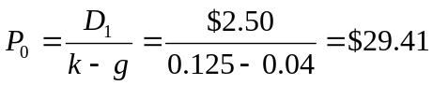

  - False. Higher beta means that the risk of the firm is higher and the discount rate applied to value cash flows is higher. For any expected path of earnings and cash flows, the present value of the cash flows, and therefore, the price of the firm will be lower when risk is higher. Thus the ratio of price to earnings will be lower.

  - True. Higher ROE means more valuable growth opportunities.

  - Uncertain. The answer depends on a comparison of the expected rate of return on reinvested earnings with the market capitalization rate. If the expected rate of return on the firm's projects is higher than the market capitalization rate, then P/E will increase as the plowback ratio increases.

  - 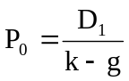

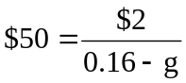 ⇒ 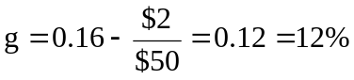

  - 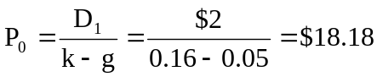

The price falls in response to the more pessimistic forecast of dividend growth. The forecast for current earnings, however, is unchanged. Therefore, the P/E ratio decreases. The lower P/E ratio is evidence of the diminished optimism concerning the firm's growth prospects.

  - g = ROE × b = 0.20 × 0.30 = 0.06 = 6.0%
D1 = $2(1 – b) = $2(1 – 0.30) = $1.40
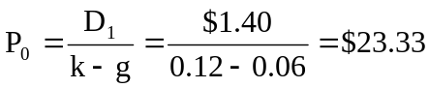
P/E = $23.33/$2 = 11.67

  - PVGO = P0 – 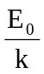= $23.33 – 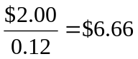

  - g = ROE × b = 0.20 × 0.20 = = 0.04 = 4.0%
D1 = $2(1 – b) = $2(1 – 0.20) = $1.60
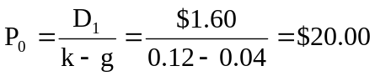
P/E = $20/$2 = 10.0
PVGO = P0 – = $20.00 – 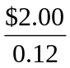= $3.33

  - g = ROE × b = 0.16 × 0.5 = 0.08 = 8.0%
D1 = $2(1 – b) = $2(1 – 0.50) = $1.00
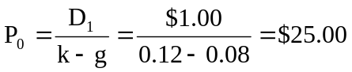

  - P3 = P0(1 + g)3 = $25(1.08)3 = $31.49

  - k = rf + β (kM – rf) = 6% + 1.25(14% – 6%) = 16%
g = (2/3) × 9% = 6%
D1 = E0 × (1 + g) × (1 – b) = $3 × 1.06 × (1/3) = $1.06
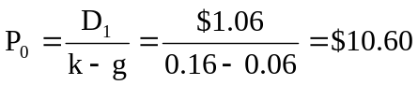

  - Leading P0/E1 = $10.60/$3.18 = 3.33
Trailing P0/E0 = $10.60/$3.00 = 3.53

  - PVGO = P0 – = $10.60 – 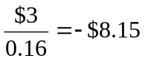
The low P/E ratios and negative PVGO are due to a poor ROE (9%) that is less than the market capitalization rate (16%).

  - Now, you revise the following:
b = 1/3
g = 1/3 × 0.09 = 0.03 = 3.0%
D1 = E0 × 1.03 × (2/3) = $2.06
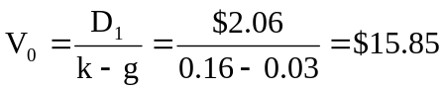
V0 increases because the firm pays out more earnings instead of reinvesting earnings at a poor ROE. This information is not yet known to the rest of the market.

- FI Corporation
  - 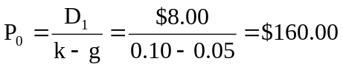
  - The dividend payout ratio is 8/12 = 2/3, so the plowback ratio is b = (1/3). The implied value of ROE on future investments is found by solving as follows:
g = b × ROE
0.05 = (1/3) × ROE ⇒ ROE = 15%

  - Assuming ROE = k, the price is (E₁/k) ⇒ P0 = $12/0.10 = $120
Therefore, the market is paying ($160 – $120) = $40 per share for growth opportunities.
- Nogro Corporation
  - D1 = 0.5 × $2 = $1
g = b × ROE = 0.5 × 0.20 = 0.10
Therefore:
k = 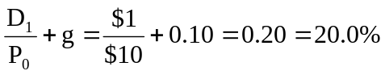
  - Since k = ROE, the NPV of future investment opportunities is zero:
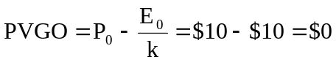
  - Since k = ROE, the stock price would be unaffected if Nogro were to cut its dividend payout ratio to 25%. The additional earnings that would be reinvested would earn the ROE (20%).
Again, if Nogro eliminated the dividend, this would have no impact on Nogro’s stock price since the NPV of the additional investments would be zero.

- Xyrong Corporation
  - k = rf + β[E(rM) – rf] = 8% + 1.2(15% – 8%) = 16.4%
g = b × ROE = 0.6 × 0.20 = 12%
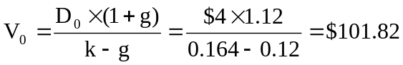
  - P1 = V1 = V0 × (1 + g) = $101.82 × 1.12 = $114.04
E(r) =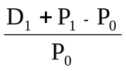= 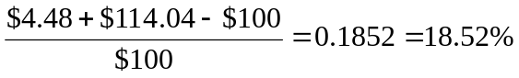

Before-tax cash flow from operations $2,100,000
Depreciation 210,000
Taxable Income 1,890,000
Taxes (@ 35%) 661,500
After-tax unleveraged income 1,228,500
After-tax cash flow from operations
(After-tax unleveraged income + depreciation) 1,438,500
New investment (20% of cash flow from operations) 420,000
Free cash flow
(After-tax cash flow from operations – new investment) $1,018,500

The value of the firm (i.e., debt plus equity) is:
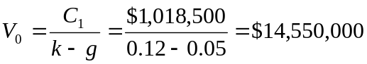
Since the value of the debt is $4 million, the value of the equity is $10,550,000.

  - Price = 20.62
  - Price = 18.95
  - Price = 20.07
Use this spreadsheet for all answers
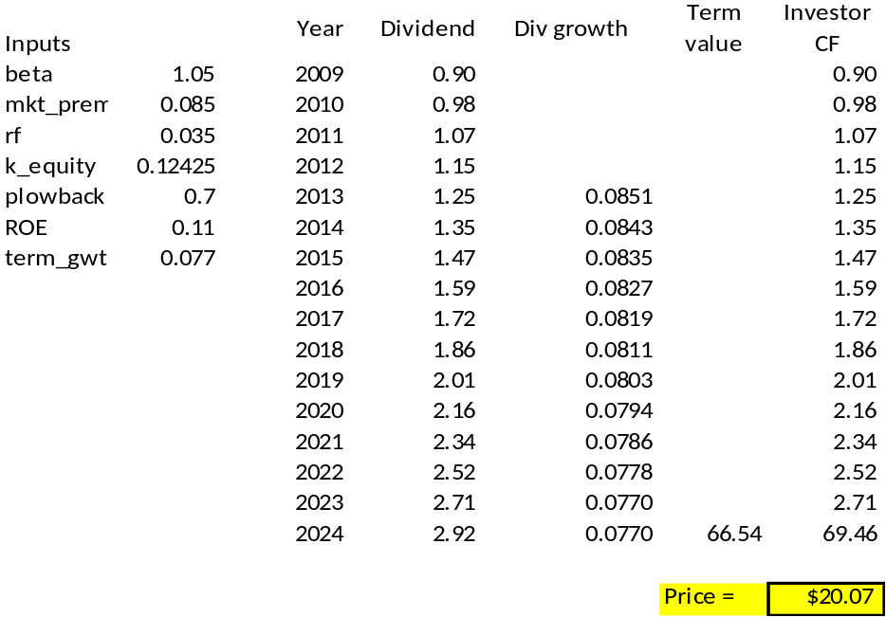

- The solutions derived from Spreadsheet 13.2 are as follows:

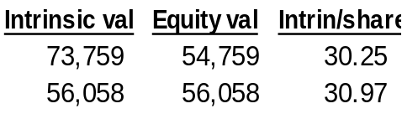
b.
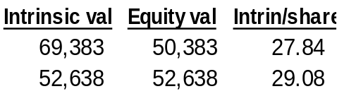

c.
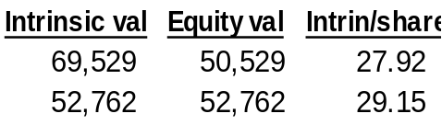

  - g = ROE × b = 20% × 0.5 = 10%
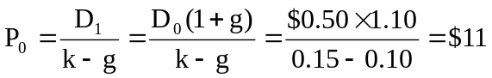

b. | Time | EPS | Dividend | Comment
 | 0 | $1.0000 | $0.5000
 | 1 | $1.1000 | $0.5500 | g = 10%, plowback = 0.50
 | 2 | $1.2100 | $0.7260 | EPS has grown by 10% based on last year’s earnings plowback and ROE; this year’s earnings plowback ratio now falls to 0.40 and payout ratio = 0.60
 | 3 | $1.2826 | $0.7696 | EPS grows by (0.4) (15%) = 6% and payout ratio = 0.60
At time 2: 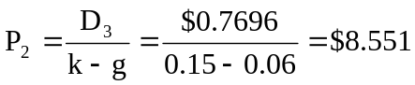
At time 0: 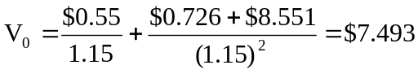

c. P₀ = $11 and P₁ = P₀(1 + g) = $12.10
(Because the market is unaware of the changed competitive situation, it believes the stock price should grow at 10% per year.)
P₂ = $8.551 after the market becomes aware of the changed competitive situation.
P3 = $8.551 × 1.06 = $9.064 (The new growth rate is 6%.)
Year | Return
1 | 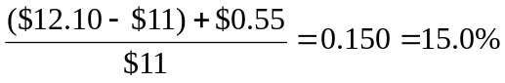
2 | 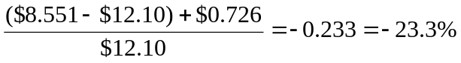
3 | 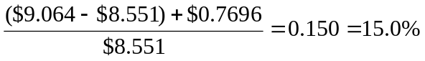
Moral: In "normal periods" when there is no special information,
the stock return = k = 15%. When special information arrives, all the abnormal return accrues in that period, as one would expect in an efficient market.

CFA 1
(a) and (b)

CFA 2
  - This director is confused. In the context of the constant growth model, it is true that price is higher when dividends are higher holding everything else (including dividend growth) constant. But everything else will not be constant. If the firm raises the dividend payout rate, then the growth rate (g) will fall, and stock price will not necessarily rise. In fact, if ROE > k, price will fall.

  - i. An increase in dividend payout reduces the sustainable growth rate as less funds are reinvested in the firm.
ii. The sustainable growth rate is (ROE × plowback), which falls as the plowback ratio falls. The increased dividend payout rate reduces the growth rate of book value for the same reason -- less funds are reinvested in the firm.

CFA 3
  - It is true that NewSoft sells at higher multiples of earnings and book value than Capital. But this difference may be justified by NewSoft's higher expected growth rate of earnings and dividends. NewSoft is in a growing market with abundant profit and growth opportunities. Capital is in a mature industry with fewer growth prospects. Both the price-earnings and price-book ratios reflect the prospect of growth opportunities, indicating that the ratios for these firms do not necessarily imply mispricing.

  - The most important weakness of the constant-growth dividend discount model in this application is that it assumes a perpetual constant growth rate of dividends. While dividends may be on a steady growth path for Capital, which is a more mature firm, that is far less likely to be a realistic assumption for NewSoft.

  - NewSoft should be valued using a multi-stage DDM, which allows for rapid growth in the early years, but also recognizes that growth must ultimately slow to a more sustainable rate.

CFA 4
a. The industry’s estimated P/E can be computed using the following model:
P₀/E₁ = payout ratio/(r − g)
However, since r and g are not explicitly given, they must be computed using the following formulas:
g_{ind} = ROE × retention rate = 0.25 × 0.40 = 0.10
r_{ind} = government bond yield + ( industry beta × equity risk premium)
= 0.06 + (1.2 × 0.05) = 0.12
Therefore:
P₀/E₁ = 0.60/(0.12 − 0.10) = 30.0

b.
    - Forecast growth in real GDP would cause P/E ratios to be generally higher for Country A. Higher expected growth in GDP implies higher earnings growth and a higher P/E.
    - ii. Government bond yield would cause P/E ratios to be generally higher for Country B. A lower government bond yield implies a lower risk-free rate and therefore a higher P/E.
    - iii. Equity risk premium would cause P/E ratios to be generally higher for Country B. A lower equity risk premium implies a lower required return and a higher P/E.

CFA 5
a. k = rf + β [Ε(rM) – rf ] = 4.5% + 1.15(14.5% − 4.5%) = 16%

b.
Year Dividends
2007 $1.72
2008 $1.72 × 1.12 = $1.93
2009 $1.72 × 1.12² = $2.16
2010 $1.72 × 1.12³ = $2.42
2011 $1.72 × 1.12³ × 1.09 = $2.63
Present value of dividends paid in years 2008 to 20010:
Year PV of Dividends
2008 $1.93/1.16¹ = $1.66
2009 $2.16/1.16² = $1.61
2010 $2.42/1.16³ = $1.55
Total: $4.82
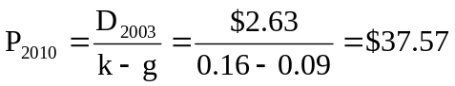
PV (in 2007) of P₂₀₁₀ = $37.57/(1.16³) = $24.07
Intrinsic value of stock = $4.82 + $24.07 = $28.89
  - The table presented in the problem indicates that Quick Brush is selling below intrinsic value, while we have just shown that Smile White is selling somewhat above the estimated intrinsic value. Based on this analysis, Quick Brush offers the potential for considerable abnormal returns, while Smile White offers slightly below-market risk-adjusted returns.

  - Strengths of two-stage DDM compared to constant growth DDM:
- The two-stage model allows for separate valuation of two distinct periods in a company’s future. This approach can accommodate life cycle effects. It also can avoid the difficulties posed when the initial growth rate is higher than the discount rate.
- The two-stage model allows for an initial period of above-sustainable growth. It allows the analyst to make use of her expectations as to when growth may shift to a more sustainable level.
- A weakness of all DDMs is that they are all very sensitive to input values. Small changes in k or g can imply large changes in estimated intrinsic value. These inputs are difficult to measure.

CFA 6
  - The value of a share of Rio National equity using the Gordon growth model and the capital asset pricing model is $22.40, as shown below.
Calculate the required rate of return using the capital asset pricing model:
k = rf + β (kM – rf) = 4% + 1.8(9% – 4%) = 13%
Calculate the share value using the Gordon growth model:
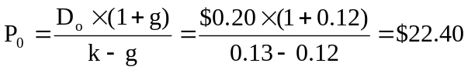

  - The sustainable growth rate of Rio National is 9.97%, calculated as follows:
g = b × ROE = Earnings Retention Rate × ROE = (1 – Payout Ratio) × ROE =

CFA 7
- To obtain free cash flow to equity (FCFE), the two adjustments that Shaar should make to cash flow from operations (CFO) are:
1. Subtract investment in fixed capital: CFO does not take into account the investing activities in long-term assets, particularly plant and equipment. The cash flows corresponding to those necessary expenditures are not available to equity holders and therefore should be subtracted from CFO to obtain FCFE.
2. Add net borrowing: CFO does not take into account the amount of capital supplied to the firm by lenders (e.g., bondholders). The new borrowings, net of debt repayment, are cash flows available to equity holders and should be added to CFO to obtain FCFE.

- Note 1: Rio National had $75 million in capital expenditures during the year.
Adjustment: negative $75 million
The cash flows required for those capital expenditures (–$75 million) are no longer available to the equity holders and should be subtracted from net income to obtain FCFE.
Note 2: A piece of equipment that was originally purchased for $10 million was sold for $7 million at year-end, when it had a net book value of $3 million. Equipment sales are unusual for Rio National.
Adjustment: positive $3 million
In calculating FCFE, only cash flow investments in fixed capital should be considered. The $7 million sale price of equipment is a cash inflow now available to equity holders and should be added to net income. However, the gain over book value that was realized when selling the equipment ($4 million) is already included in net income. Because the total sale is cash, not just the gain, the $3 million net book value must be added to net income. Therefore, the adjustment calculation is:
$7 million in cash received – $4 million of gain recorded in net income =
$3 million additional cash received that must be added to net income to obtain FCFE.
Note 3: The decrease in long-term debt represents an unscheduled principal repayment; there was no new borrowing during the year.
Adjustment: negative $5 million
The unscheduled debt repayment cash flow (–$5 million) is an amount no longer available to equity holders and should be subtracted from net income to determine FCFE.
Note 4: On 1 January 2009, the company received cash from issuing 400,000 shares of common equity at a price of $25.00 per share.
No adjustment
Transactions between the firm and its shareholders do not affect FCFE. To calculate FCFE, therefore, no adjustment to net income is required with respect to the issuance of new shares.
Note 5: A new appraisal during the year increased the estimated market value of land held for investment by $2 million, which was not recognized in 2009 income.
No adjustment
The increased market value of the land did not generate any cash flow and was not reflected in net income. To calculate FCFE, therefore, no adjustment to net income is required.

- Free cash flow to equity (FCFE) is calculated as follows:
FCFE = NI + NCC – FCINV – WCINV + Net Borrowing
where NCC = non-cash charges
FCINV = investment in fixed capital
WCINV = investment in working capital
 | Million $ | Explanation
NI = | $30.16 | From Exhibit 18B
NCC = | +$67.17 | $71.17 (depreciation and amortization from Exhibit 18B)  – $4.00* (gain on sale from Note 2)
FCINV = | –$68.00 | $75.00 (capital expenditures from Note 1)  – $7.00* (cash on sale from Note 2)
WCINV = | –$24.00 | –$3.00 (increase in accounts receivable from Exhibit 18A +  –$20.00 (increase in inventory from Exhibit 18A) +  –$1.00 (decrease in accounts payable from Exhibit 18A)
Net Borrowing = | +(–$5.00) | –$5.00 (decrease in long-term debt from Exhibit 18A)
FCFE = | $0.33
*Supplemental Note 2 in Exhibit 18C affects both NCC and FCINV.

CFA 8
Rio National’s equity is relatively undervalued compared to the industry on a P/E-to-growth (PEG) basis. Rio National’s PEG ratio of 1.33 is below the industry PEG ratio of 1.66. The lower PEG ratio is attractive because it implies that the growth rate at Rio National is available at a relatively lower price than is the case for the industry. The PEG ratios for Rio National and the industry are calculated below:
Rio National
Current Price = $25.00
Normalized Earnings per Share = $1.71
Price-to-Earnings Ratio = $25/$1.71 = 14.62
Growth Rate (as a percentage) = 11
PEG Ratio = 14.62/11 = 1.33
Industry
Price-to-Earnings Ratio = 19.90
Growth Rate (as a percentage) = 12
PEG Ratio = 19.90/12 = 1.66

CFA 9
Using a two-stage dividend discount model, the current value of a share of Sundanci is calculated as follows:
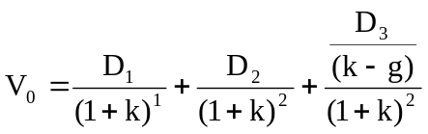
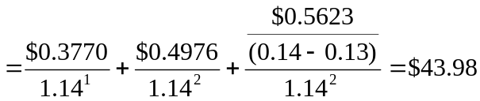
where:
E₀ = $0.952
D₀ = $0.286
E₁ = E₀ (1.32)¹ = $0.952 × 1.32 = $1.2566
D₁ = E₁ × 0.30 = $1.2566 × 0.30 = $0.3770
E₂ = E₀ (1.32)² = $0.952 × (1.32)² = $1.6588
D₂ = E₂ × 0.30 = $1.6588 × 0.30 = $0.4976
E₃ = E₀ × (1.32)² × 1.13 = $0.952 × (1.32)³ × 1.13 = $1.8744
D₃ = E₃ × 0.30 = $1.8744 × 0.30 = $0.5623

CFA 10
  - Free cash flow to equity (FCFE) is defined as the cash flow remaining after meeting all financial obligations (including debt payment) and after covering capital expenditure and working capital needs. The FCFE is a measure of how much the firm can afford to pay out as dividends, but in a given year may be more or less than the amount actually paid out.
Sundanci's FCFE for the year 2010 is computed as follows:
FCFE =
Earnings after tax + Depreciation expense − Capital expenditures − Increase in NWC =
$80 million + $23 million − $38 million − $41 million = $24 million
FCFE per share = FCFE/number of shares outstanding =
$24 million/84 million shares = $0.286
At the given dividend payout ratio, Sundanci's FCFE per share equals dividends per share.

  - The FCFE model requires forecasts of FCFE for the high growth years (2011 and 2012) plus a forecast for the first year of stable growth (2013) in order to allow for an estimate of the terminal value in 2012 based on perpetual growth. Because all of the components of FCFE are expected to grow at the same rate, the values can be obtained by projecting the FCFE at the common rate. (Alternatively, the components of FCFE can be projected and aggregated for each year.)
The following table shows the process for estimating Sundanci's current value on a per share basis:

Free Cash Flow to Equity
Base Assumptions
Shares outstanding: 84 millions
Required return on equity (r): 14%
 |  | Actual  2010 |  | Projected  2011 |  |  | Projected  2012 | Projected  2013
Growth rate (g) |  |  |  | 27% |  |  | 27% | 13%
 | Total | Per share
Earnings after tax | $80 | $0.952 |  | $1.2090 |  |  | $1.5355 | $1.7351
Plus: Depreciation expense | $23 | $0.274 |  | $0.3480 |  |  | $0.4419 | $0.4994
Less: Capital expenditures | $38 | $0.452 |  | $0.5740 |  |  | $0.7290 | $0.8238
Less: Increase in net working capital | $41 | $0.488 |  | $0.6198 |  |  | $0.7871 | $0.8894
Equals: FCFE | $24 | $0.286 |  | $0.3632 |  |  | $0.4613 | $0.5213
Terminal value |  |  |  |  |  |  | $52.1300*
Total cash flows to equity |  |  |  | $0.3632 |  |  | $52.5913**
Discounted value |  |  |  | $0.3186*** |  |  | $40.4673***
Current value per share |  |  |  |  |  | $40.7859****
*Projected 2012 Terminal value = (Projected 2013 FCFE)/(r − g)
**Projected 2012 Total cash flows to equity =
Projected 2012 FCFE + Projected 2012 Terminal value
***Discounted values obtained using r = 14%
****Current value per share =
Sum of Discounted Projected 2011 and 2012 Total cash flows to equity
  - i. The following limitations of the dividend discount model (DDM) are addressed by the FCFE model. The DDM uses a strict definition of cash flows to equity, i.e. the expected dividends on the common stock. In fact, taken to its extreme, the DDM cannot be used to estimate the value of a stock that pays no dividends. The FCFE model expands the definition of cash flows to include the balance of residual cash flows after all financial obligations and investment needs have been met. Thus the FCFE model explicitly recognizes the firm’s investment and financing policies as well as its dividend policy. In instances of a change of corporate control, and therefore the possibility of changing dividend policy, the FCFE model provides a better estimate of value. The DDM is biased toward finding low PIE ratio stocks with high dividend yields to be undervalued and conversely, high PIE ratio stocks with low dividend yields to be overvalued. It is considered a conservative model in that it tends to identify fewer undervalued firms as market prices rise relative to fundamentals. The DDM does not allow for the potential tax disadvantage of high dividends relative to the capital gains achievable from retention of earnings.
ii. The following limitations of the DDM are not addressed by the FCFE model. Both two-stage valuation models allow for two distinct phases of growth, an initial finite period where the growth rate is abnormal, followed by a stable growth period that is expected to last indefinitely.. These two-stage models share the same limitations with respect to the growth assumptions. First, there is the difficulty of defining the duration of the extraordinary growth period. For example, a longer period of high growth will lead to a higher valuation, and there is the temptation to assume an unrealistically long period of extraordinary growth. Second, the assumption of a sudden shift form high growth to lower, stable growth is unrealistic. The transformation is more likely to occur gradually, over a period of time. Given that the assumed total horizon does not shift (i.e., is infinite), the timing of the shift form high to stable growth is a critical determinant of the valuation estimate. Third, because the value is quite sensitive to the steady-state growth assumption, over- or under-estimating this rate can lead to large errors in value. The two models share other limitations as well, notably difficulties inaccurately forecasting required rates of return, in dealing with the distortions that result from substantial and/or volatile debt ratios, and in accurately valuing assets that do not generate any cash flows.

CFA 11
- The formula for calculating a price earnings ratio (P/E) for a stable growth firm is the dividend payout ratio divided by the difference between the required rate of return and the growth rate of dividends. If the P/E is calculated based on trailing earnings (year 0), the payout ratio is increased by the growth rate. If the P/E is calculated based on next year’s earnings (year 1), the numerator is the payout ratio.
P/E on trailing earnings:
P/E = [payout ratio × (1 + g)]/(r − g) = [0.30 × 1.13]/(0.14 − 0.13) = 33.9
P/E on next year's earnings:
P/E = payout ratio/(r − g) = 0.30/(0.14 − 0.13) = 30.0

- The P/E ratio is a decreasing function of riskiness; as risk increases the P/E ratio decreases. Increases in the riskiness of Sundanci stock would be expected to lower the P/E ratio.
The P/E ratio is an increasing function of the growth rate of the firm; the higher the expected growth the higher the P/E ratio. Sundanci would command a higher P/E if analysts increase the expected growth rate.
The P/E ratio is a decreasing function of the market risk premium. An increased market risk premium would increase the required rate of return, lowering the price of a stock relative to its earnings. A higher market risk premium would be expected to lower Sundanci's P/E ratio.

